

**Capstone Project 1**

**CMU-SE 450**

**Database Design**

**Version 1.1**

**Date: 25/03/2023**

**LinguaSnap for Travelers**

**Submitted by**

**Dat, Nguyen Thanh**

**Truong, Vu Dinh**

**Long, Pham Ba Hoang**

**Kha, Nguyen Ngoc**

**Approved by Nguyen Duc Man**

**Capstone Project 1- Mentor:**

Name Signature Date

**INTERNATIONAL SCHOOL OF DUY TAN UNIVERSITY**

**PROJECT INFORMATION**

|  |  |  |  |
| --- | --- | --- | --- |
| **Project acronym** | LiS | | |
| **Project title** | LinguaSnap for Travelers | | |
| **Start date** | 25 – February – 2023 | **End Date** | 31 – May – 2023 |
| **Lead institution** | International School, Duy Tan University | | |
| **Project mentor** | Nguyen Duc Man  Email: mannd@duytan.edu.vn  Phone: +84 904 235 945 | | |
| **Partner organization** | Duy Tan University | | |
| **Scrum Master** | Dat, Nguyen Thanh | ntdat1232001@gmail.com | 0972530969 |
| **Product owner** | Truong ,Vu Dinh | jonnyvu2210@gmail.com | 0905223611 |
| **Team members** | Kha, Nguyen Ngoc | winkha14567@gmail.com | 0945721427 |
| Long, Pham Ba Hoang | longphambahoang@gmail.com | 0793310221 |

**DATABASE DESIGN DOCUMENT**

|  |  |  |  |
| --- | --- | --- | --- |
| **Document Title** | Database Design Document |  |  |
| **Reporting Period** |  |  |  |
| **Author(s)** | Truong, Vu Dinh | |  |
| **Team Information** | **Name** | **Role** |  |
| Dat, Nguyen Thanh | Leader |  |
| Truong ,Vu Dinh | Member |  |
| Kha, Nguyen Ngoc | Member |  |
| Long, Pham Ba Hoang | Member |  |
| **Date** | 25/03/2023 | **Filename** | C1SE.05_LiS_Database_Design_V1.1.docx |
| **Access** | Project and CMU Program | |  |

**REVISION HISTORY**

|  |  |  |  |  |
| --- | --- | --- | --- | --- |
| **Version** | **Date** | **Comments** | **Author** | **Approval** |
| 1.0 | 15/03/2023 | Initial Release | All members | x |
| 1.1 | 25/03/2023 | Update document | Truong | offical |

**Document Approvals**

The following signatures are required for approval of this document:

|  |  |  |
| --- | --- | --- |
| **Document Approval** | | |
| Man, Nguyen Duc(Ph.D)  Mentor |  | Date: |
| Dat, Nguyen Thanh  Scrum master, DevTeam |  | Date |
| Truong, Vu Dinh  Product Owner, DevTeam |  | Date |
| Long, Pham Ba Hoang  DevTeam |  | Date |
| Kha, Nguyen Ngoc  DevTeam |  | Date |

**TABLE OF CONTENTS**

1. Introduction 5

1.1. Purpose 5

1.2. Goal 5

2. Database Design Decision 6

2.1. Mapping Rules 6

2.2. Tables relationship diagram 7

3. Table 8

3.1. Overview 8

3.2. Table detail 8

3.2.1. User 8

3.2.2. ID 8

3.2.3. Profile 8

3.2.4. History 9

3.2.5. Bookmark 9

2. **Introduction**
   1. **Purpose**

- Setting up an overview of the database system's interview preparation app.

- Provides database tables needed by the system and the relationship between common for programmers.

- Description designing a database (DB), a collection of data related to storage on a computer through a database management system as a basis for data query related software.

- Provide the entire needed database for the Interview Preparation Application.

* 1. **Goal**

- This Database Design Document describes the design of a database, that is, a collection of related data stored in one or more computerized files that can be accessed by users or developers via Firebase.

- It describes both logical and physical definition, non-functional, database interfaces, tables, code create tables.

- It includes the tables and performance considerations and requirements. The following topics are covered in this document:

● Assumptions and decisions on database design

● Entity – mapping

● Table, column definitions

● Constraint: primary key, unique, foreign key.

● Column and row level validation rules (check constraints)

● Interfaces and dependencies with other components.

- This Database Design Document of Interview Preparation Application is composed of definitions for database objects derived by mapping entities to tables, attributes to columns, unique identifiers to unique keys and relationship to foreign keys.

- During design, these initial definitions are enhanced to support the functionality described in the functional specification / user stories and defined in the primary and supporting modules of the application high level design

**Hardware and Software Requirement**

|  |  |
| --- | --- |
| **The technology component** | |
| **Attribute** | **Description** |
| Database | Firebase |
| Hardware | Android Mobile |

1. **Database Design Decision**

This section contains the decisions that were made when designing the database for the project. Problems, alternative solutions, and motivated choices are listed below. The section also lists any design assumptions that had to be made. In case the assumptions are results of ambiguities or lack of details, they will need verifying by the analyst team.

* 1. **Mapping Rules**

**●** The additional data will be stored as a free JSON structured format or "document", where the data can be in any form from integers to data strings to custom formatted text.

● Entities are mapped into tables in a one to one manner.

● Real-time database

● Real-time sync

● Non-relational

* 1. **Tables relationship diagram**

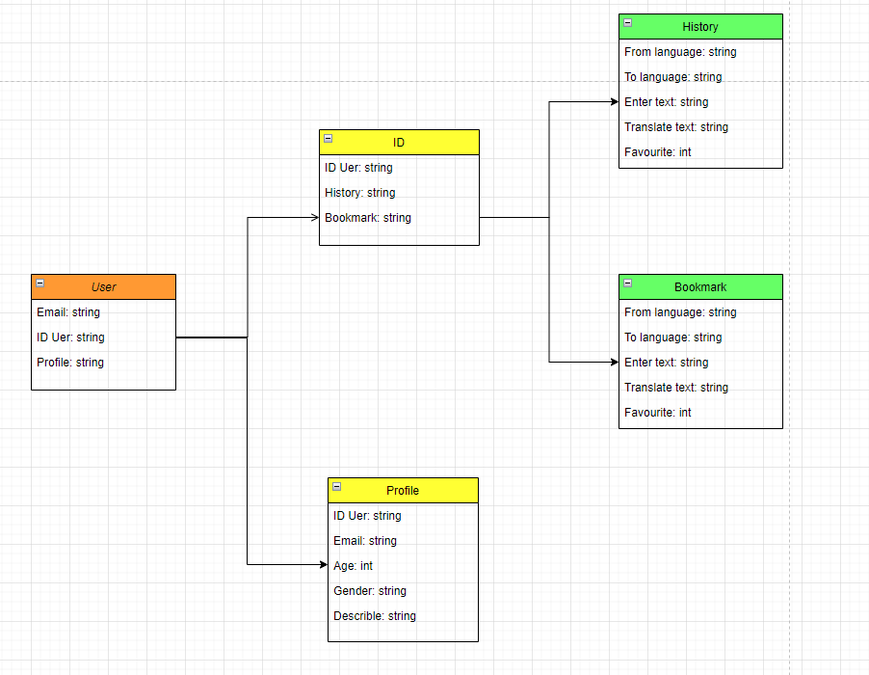

**Picture 1: Tables relationship diagram**

1. **Table**
   1. **Overview**

|  |  |  |
| --- | --- | --- |
| **No** | **Table name** | **Short description** |
| **1** | User | Email and ID user |
| **2** | ID | History and Bookmark |
| **3** | Profile | Information of user |
| **4** | History | Data of translation |
| **5** | Bookmark | Data of bookmark |

* 1. **Table detail**
     1. **User**

This included the following information: **ID, Email, Profile**

|  |  |  |  |
| --- | --- | --- | --- |
| **ID** | **Field** | **Data Type/ size** | **Constraints** |
| 1 | **ID** | Text string | NOT NULL |
| 2 | **Email** | Text string | NOT NULL |
| 3 | **Profile** | Text string |  |

* + 1. **ID**

This included the following information: **ID User, History, Bookmark**

|  |  |  |  |
| --- | --- | --- | --- |
| **ID** | **Field** | **Data Type/ size** | **Constraints** |
| 1 | **ID User** | TEXT STRING | NOT NULL |
| 2 | **History** | TEXT STRING |  |
| 3 | **Bookmark** | TEXT STRING |  |

* + 1. **Profile**

This included the following information: **ID User, Email, Age, Gender, Describle**

|  |  |  |  |
| --- | --- | --- | --- |
| **ID** | **Field** | **Data Type/ size** | **Constraints** |
| 1 | **ID User** | TEXT STRING | NOT NULL |
| 2 | **Email** | TEXT STRING | NOT NULL |
| 3 | **Age** | INT |  |
| 4 | **Gender** | TEXT STRING |  |
| 5 | **Describle** | TEXT STRING |  |

* + 1. **History**

This included the following information: **From language, To language, Enter text, Translate text, Favourite**

|  |  |  |  |
| --- | --- | --- | --- |
| **ID** | **Field** | **Data Type/ size** | **Constraints** |
| 1 | **From language** | TEXT STRING |  |
| 2 | **To language** | TEXT STRING |  |
| 3 | **Enter text** | TEXT STRING |  |
| 4 | **Translate text** | TEXT STRING |  |
| 5 | **Favourite** | INT | NOT NULL |

* + 1. **Bookmark**

This included the following information: **From language, To language, Enter text, Translate text, Favourite**

|  |  |  |  |
| --- | --- | --- | --- |
| **ID** | **Field** | **Data Type/ size** | **Constraints** |
| 1 | **From language** | TEXT STRING |  |
| 2 | **To language** | TEXT STRING |  |
| 3 | **Enter text** | TEXT STRING |  |
| 4 | **Translate text** | TEXT STRING |  |
| 5 | **Favourite** | INT | NOT NULL |